## Darshan Nikam Date: 07/03/2024

### **Apache Tomcat web server**

Apache Tomcat is a free software created by a group called the Apache Software Foundation. It's like a toolbox specifically designed to help run websites and applications that are built using Java programming language.

Imagine you have a special room where you want to showcase various items. Tomcat acts as the caretaker of that room. It knows how to handle different tasks like displaying the items, managing requests from visitors, and ensuring everything runs smoothly.

Tomcat follows a set of rules called Java EE, which helps developers build complex web applications. It's like having a rulebook that guides you on how to create and manage your website or application.

One of the advantages of Tomcat is that it's written in Java itself. So, it's like having a system that speaks the same language throughout, making it easier for different parts to work together seamlessly.

In simple terms, Apache Tomcat helps websites and applications written in Java to operate effectively on the internet, providing a reliable platform for developers to showcase their projects.

By default, Tomcat listens for HTTP requests on port 8080.

**Now we install the Apache tomcat server on the Ec2 Instance** a**nd host a website using the tomcat server.**

1. Launch Ec2 Instance. (Allow Rules SSH, HTTP, and custom TCP on port 8080)
2. Connect the Instance.
3. Go to the web browser search for Apache Tomcat download, and copy the download URL.
4. Also, we need a web template to host the website, search for free website template download, and copy the download link. (keep both links in Notepad)
5. Now run the following commands on your Ec2 CLI.

* **curl -O <download URL of apache tomcat>** -> Apache package directory will download in zip file
* **ls** - > to list (downloaded package name **apache-tomcat-9.0.86.zip**)
* **unzip apache-tomcat-9.0.86.zip** -> to unzip the package
* **curl -O <template download link** -> template will download in the zip file
* **ls** -> to list, check the downloaded template name
* **unzip <template>** -> to unzip template.
* **mv template apache-tomcat-9.0.86/webapps** -> mv template to webapps directory

("webapps" specifically refers to the directory where you deploy web applications or websites for Tomcat to host)

* **yum install java -y** -> to install java package

(Apache Tomcat itself Java application so it needs a Java environment to run)

* **chmod 777 apache-tomcat-9.0.86/bin/catalina.sh** -> to give full permission to **[catilnia.sh]** file.

Giving full permission to **catalina.sh** file, to execute the script. The script is to be used to start, stop, and manage the Tomcat server.

* **./apache-tomcat-9.0.86/bin/catalina.sh start** -> to start the tomcat server.

**Now our web website is deployed on the Tomcat server.**

When we install and configure Apache Tomcat, we can access the Tomcat server's default web application by navigating to **http://localhost:8080** in your web browser.

To access our web application (template) we need to give the resource path as **http://localhost:8080/template.** (Here local host is our Ec2 instance so we use the public IP of the instance)

**Here are some screenshots of the above process.**

1. **Custom TCP Port 8080 Allowing.**

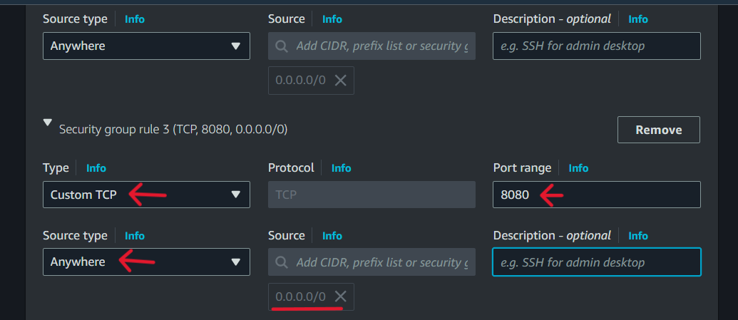

1. **Apache Tomcat Download**

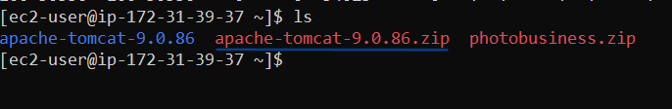

1. **Directories and files under Apache Tomcat**

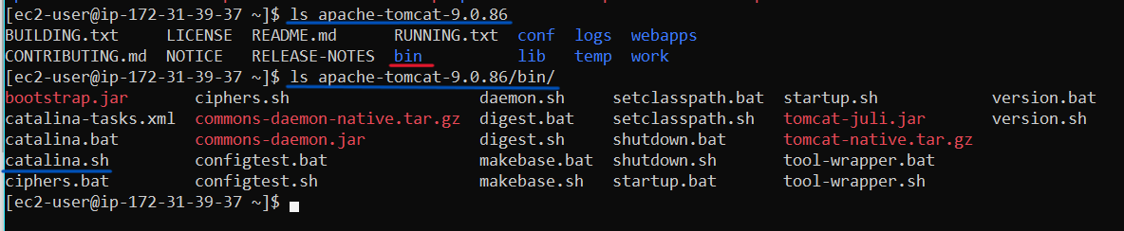

1. The downloaded template is a pre-configured website and we moved it to the webapps directory.

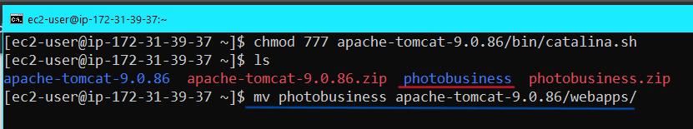

1. Giving full permission for **catalina.sh** file

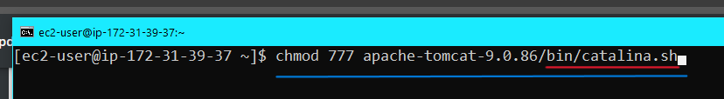

1. Accessing Web application

